Ideation Phase
Brainstorm & Idea Prioritization Template

Date | 20 February 2026
Team ID | LTVIP2026TMIDS24292
Project Name | LearnHub : Your Center For Skill Enhancement
Maximum Marks | 4 Marks

Brainstorm & Idea Prioritization Template:
Brainstorming in the LearnHub project creates an open and collaborative environment where all team members actively participate in generating ideas to solve real-world skill development challenges. The focus is on encouraging diverse and innovative thinking, allowing team members to freely propose ideas without immediate judgment. Emphasis is placed on generating a large number of ideas first, which are later refined and evaluated based on feasibility, impact, and alignment with project goals.
This brainstorming and idea prioritization approach enables the team to collaboratively design effective features such as structured learning paths, skill-based courses, and progress tracking mechanisms. The template supports both in-person and remote collaboration, ensuring that creativity and teamwork are maintained regardless of physical location. By following this method, the LearnHub team can systematically transform creative ideas into practical solutions that enhance the learning experience for users.
Step-1: Team Gathering, Collaboration and Select the Problem Statement
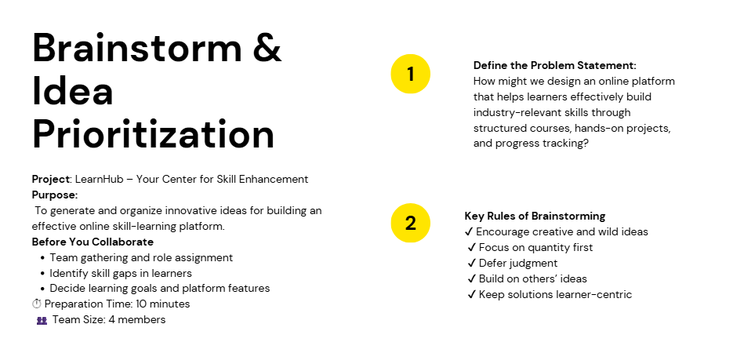Step-2: Brainstorm, Idea Listing and Grouping
In this phase, the team conducted a brainstorming session to generate diverse ideas that address the problem of providing effective and accessible skill-based education through an online platform. All team members actively contributed ideas without judgment, focusing on creativity, innovation, and learner-centric solutions. The goal was to generate a wide range of ideas before evaluating or filtering them.

Idea Listing
The following ideas were generated during the brainstorming session:
- Skill-based courses covering beginner to advanced levels
- Personalized learning paths based on user goals
- Hands-on projects and real-world case studies
- Interactive quizzes and module-wise assessments
- Progress tracking and performance analytics dashboard
- Course completion certificates
- Mobile-friendly and responsive user interface
- Easy navigation and user-friendly design
- Affordable and accessible learning resources

Idea Grouping
The generated ideas were grouped into related categories to organize them systematically:
- Learning Content
  - Skill-based courses
  - Structured learning paths
  - Industry-relevant syllabus
- Practical Learning
  - Hands-on projects
  - Case studies
  - Course certifications
- Evaluation & Tracking
  - Quizzes and assessments
  - Progress tracking dashboard
  - Performance analytics
- User Experience
  - Responsive web design
  - Mobile compatibility
  - Simple and intuitive navigation
This structured grouping helped the team identify core features and focus areas of the LearnHub platform, forming a strong foundation for the idea prioritization phase.
Step-3: Idea Prioritization


